**Block Diagram**

Team MG 4: Team #UNO

Dakota Moore

Alexander Schulz

Zachary Frisvold

Conghui Si

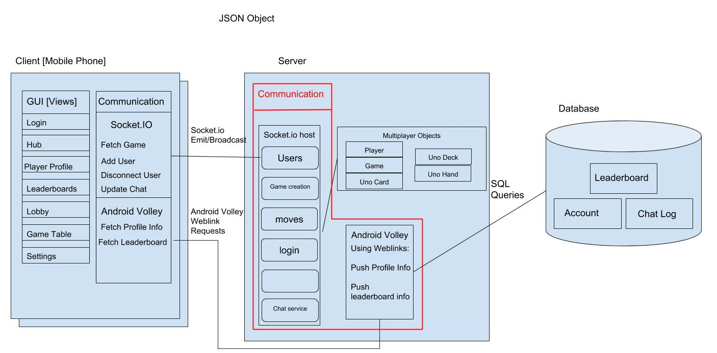

Page 3: Design Description

Client GUI:

The Uno application client side have login activity, lobby activity, single player activity and multiplayer activity, and each activity’s interface is written in xml, lifecycle requirements are written in Java. When client login through the login activity, his/her username will be carried to the lobby activity via intent. When multiplayer activity is activated, the most recent 4 users will be added to the game room, and the screen will use bright color to indicate the current turn and current score to users. All the communication with server via lobby activity, multiplayer game activity will run on the UI thread.

Communication:

**Client – Server:** Our communication model is server-client model, which is all users send messages to the server, and server will manipulate the information with game logic functions and finally send the needed to all users or to users in the same room. The lobby activity implements socket.io to communicate with our server, when lobby activity is created, username will be sent to server, then server will check if the username already existed and return all the active users to the client screen. When server detects a new user, the username will be added to our database and lobby screen will be updated. All the communications utilize JSON for data transformation, and JSONArray to parse usernames and Uno cards.

**Database – Server:** We utilizes SQL for database construction. When user logged in, server will check existence with the database. If user exists, then after game operation, database will have the score of this user and update the total score of this user, then a new leaderboard ranking will be send to server and leaderboard view on client device will be updated.

Model:

**Single player mode:** we have the game logic runs on client devices, the CPU players move will be auto-generated on client devices after client’s fist move. Overall, in this mode, everything is running locally, and we do not record these game scores into the database.

**Multiplayer mode:** When there are at least 2 users ready to play in multiplayer mode, the server will initiate a game with all global variables generated. The global variables in a game includes players, Uno Deck, Uno cards, current turn, etc. The first user joined the game room will be set as current turn by default. Whenever user pick a card, the card info will be send to server, and server will manipulate with game logic and send the updated game info back to clients. The purpose of this setting is to be able to have a nice flow between server and clients, the integrated update can help making synchronized update for different players after each move.

